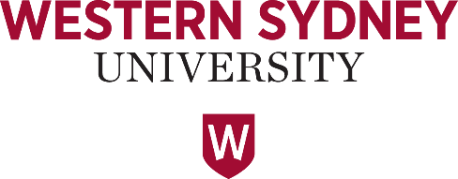
Future Earth Australia and Western Sydney University present:
Beyond SDG 11: A focus on environmental sustainability and liveable cities
20 -22 April 2020, Parramatta Campus, Western Sydney University
Please email to: futureearthaustralia@science.org.au by 11.59pm Sunday 8 March as a word document.
Successful applicants will be notified by 13 March 2020
1. CONTACT DETAILS:
Title: | Family Name: | Given Name(s):
University/Organisation: |  | Department/School:
Email: |  | Tel:
2. PERSONAL DETAILS:
Current job title: | Main professional interests:
Most recent qualification: | Date awarded and career disruptions (if applicable):
Twitter handle (if available):
3. SUBMISSION DETAILS:
Abstract Title:
Authors:

4. PRESENTATION:
Abstract (max 250 words):

Alignment of abstract with SDG 11 (100 words):

5. PERMISSION TO DISTRIBUTE/ PHOTOGRAPH:
If I am selected to participate in the Workshop/Forum I give permission for Future Earth Australia and/or Western Sydney University to a) distribute to their members versions of the full abstract and presentation and b) take photographs and/or videos during the event to be used for educational, marketing, or other purposes.
Applicant/Author’s Name:……………………………………………………………………………………………………………
Applicant/Author’s
Signature:…………………………………………………………………………… Date:…………………

