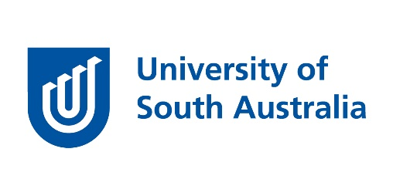
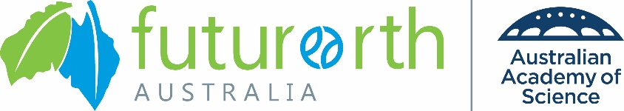
Future Earth Australia and the University of South Australia present:
The Future of Food: Connecting the UN Sustainable Development Goals
9 – 11 December 2019, City West Campus, The University of South Australia
Please email to: futureearthaustralia@science.org.au by 11.59pm Sunday 3 November as a word document.
Successful applicants will be notified by 10 November 2019
1. CONTACT DETAILS:
Title: | Family Name: | Given Name(s):
University/Organisation: |  | Department/School:
Email: |  | Tel:
2. PERSONAL DETAILS:
Current job title: | Main professional interests:
Most recent qualification: | Date awarded and career disruptions (if applicable):
Staff website and/or LinkedIn profile (if available): | Twitter handle (if available):
3. SUBMISSION DETAILS:
Abstract Title:
Authors:
4. REFEREE (academic, industry, government or not-for-profit organisation):
Name:
Position:
University/ Organisation:
Email:
5. PRESENTATION:
Abstract (max 250 words):

Alignment of abstract with the UN Sustainable Development Goals (100 words)
Indicate which of the SDGs are relevant to your work. Details are available from the UN SDG website: https://sustainabledevelopment.un.org/sdgs
6. PERMISSION TO PUBLISH/UPLOAD TO WEBSITE:
If I am selected to participate in the Workshop/Forum I give permission for Future Earth Australia and/or the University of South Australia to distribute to their members versions of the full abstract and presentation.
Applicant/Author’s Name:……………………………………………………………………………………………………………
Applicant/Author’s
Signature:…………………………………………………………………………… Date:…………………

